**TASK 1.3: FINANCIAL ANALYSIS FOR BUSINESS CASE**

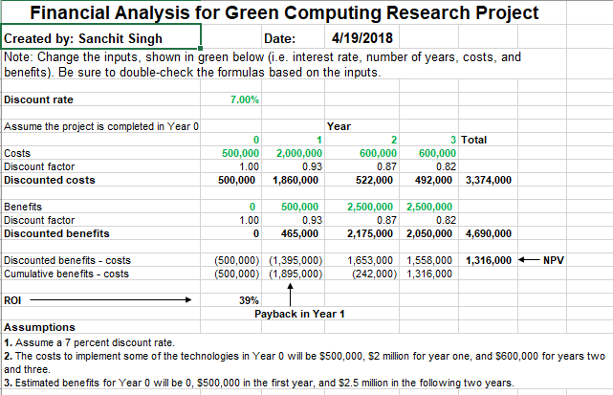

**Figure 3: Financial Analysis for Business Case**

The figure above showcases the results of the financial section of a business case for the Green Computing Research Project. On the bottom left of the figure, it can be outlined that there are three assumptions which helped calculate the discounted factor, discounted costs, discounted benefits, total NPV, and ROI. The template helped us calculate the discount factor at 1.00, 0.93, 0.87 and 0.82 for each consecutive year 0,1,2 and 3. The total NPV for our business case is $1.3 million at the end of Year 3. The “Discounted benefits – costs“ shows that there is no payback calculated till the end of Year 1, however the results are different in the following years. For Year 2 the payback is estimated to be $1,653,000 and for Year 3 the amount is $1,558,000. The ROI of 39% seems promising, which is a progressive result for a new project. To summarize, as per the assumptions and results, the range of investment offered over the consecutive years will provide promising results in the long run.